Tackle It

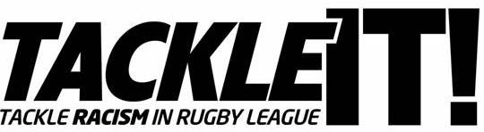

Club Tackle It! Policy

Portico Vine Amateur Rugby League Football Club acknowledges its responsibility in line with the principles of Tackle It!

Zero Tackle – Zero Tolerance
- Portico Vine ARLFC has a policy of ZERO TOLERANCE of racism in any form

First Tackle - Policies
- Portico Vine ARLFC has made a commitment to ensuring that players, spectators, staff and volunteers can enjoy an environment free of discrimination and racism and has the written policies, regulations and conditions in place to support this commitment.

Second Tackle – Communication
- Portico Vine ARLFC has nominated a senior member of staff or Officer to take a lead on its policies on racial equality and has published its policies, ground regulations and other documents which support the Club’s commitment.

This person is: Kieran Lacey

- Portico Vine ARLFC also commits to using all available means within its ground to communicate its anti racism stance including programme & scoreboard notices and PA announcements.

Third Tackle – Prevention
- Portico Vine ARLFC undertakes to Prevent spectators who take part in racist chanting, abuse or harassment from attending matches at their grounds and will ensure that any spectator who takes part in racist chanting, abuse or harassment is ejected from the ground - where an individual cannot be identified warnings should be issued with the ultimate sanction that the game be abandoned.
- The club also commits to take specific action in line with the club’s policy against players, officials or spectators who engage in racist chanting or abuse or harassment

Fourth Tackle – Education & Procedures
- Portico Vine ARLFC will adopt the RFL Equity Statement and ensure that Equality and Diversity training is delivered to all relevant staff.

Fifth Tackle – Partnership & Diversity
- Portico Vine ARLFC will undertake to co-operate to their best endeavours with BME (Black and Minority Ethnic) community leaders, groups, agencies, and media outlets as they seek to promote awareness of ethnicity and associated inclusion issues and to combat racism and to ensure that development strategies reflect the need to encourage involvement in Rugby League across all communities including black and minority ethnic communities

Sixth Tackle – The Outcome
- Portico Vine ARLFC is committed to ensuring Rugby League is a truly inclusive, uncompromising, family game.

Signed on behalf of the Club by Chairperson

Name: Andrew Connor Date: 10.01.17

